**Cariboo Lake Results Draft**

By Alex Cebulski

June 9, 2020

Revision 1

**Sub-bottom Acoustics**

Acoustic stratigraphy from six selected transects conducted across Cariboo Lake reveal the range of morphologies and character of sedimentary deposis in Cariboo Lake (Fig. 2). Acoustic penetration is limited in coarser sediments from transects proximal to river fan-deltas across Cariboo Lake (see Figure 1 for fan-delta locations). Penetration, resolution and distinctive acoustic layering improves significantly along the thalweg of the lake bottom and in cross-lake transects more distal from the fan-deltas. Cross-hatching is observed over most of the acoustic record due to errant electrical interference from the research vessel but the interference does not affect the overall quality of the results in the six selected transects.

{Caption for Figure 2 should read: Cariboo Lake sub-bottom acoustic transects with six selected transects labelled and shown in bold.} Note. Figure 2 should label with arrows the inflow and outflow locations of CL – the novice reader would not know which way water flows through the lake and which end is “up-lake” for viewing subsequent figures

Transect A, one kilometre southwest of the headwater Cariboo River delta, has a strong acoustic reflector at the sediment-water interface indicating the presence of courser-grained material on the lake bed (Fig. 3). A high fraction of sandy materials in this transect act as an acoustic mask limiting the penetration of the acoustic signal to a depth of 1-2 m. An acoustic multiple is observed 45 m below the sediment surface (Fig. 2). Acoustically penetrable, well-layered sediment is observed 3.5 km from the Cariboo River delta in transect B (Fig. 4). Acoustic reflectors with 1-2 m spacing lies conformably over a hummocky basement, with a maximum observable sediment thickness of 15-20 m observed near the thalwag. Well structured layering extends across the south side of the transect but pinches out towards the north shore.

{fix caption in Fig 3. Replace the work duplicate with “acoustic echo (multiple) is denoted by ? (there is no visible i in my copy – make label bold. Looking up lake see Figure 2 (not 3-5) for locations

{Fig 4 capture – see fig 2 for locations. Say weak multiple (echo) is visible at (i)

Acoustic penetration increases in locations about 4.5 km from the Cariboo River delta at transect C (Fig. 5). The acoustic record along this transect reaches a maximum sediment thickness of 35 m in two troughs - the maximum thickness of surficial sediments observed across Cariboo Lake in this study. The acoustic basement is considered to be either bedrock or coarse-grained glacial sediment from the Last Glacial Maximum (Fig. 5, i). Two sediment facies are observed across this transect based on geometry and the strength and continuity of reflectors. Some disruption of these facies is caused by slumping of side slopes (e.g. north end of transect C). The lower unit, facies A, has a thickness of ~ 12 m along undisturbed sections (Fig. 5, A) and is more massive to weakly acoustically layered. The contact with overlying sediment above facies A appears to be conformable at the south end and middle of the transect but unconformable in other places. The unconformities are most apparent in the two sharp crested v-notch channels at the middle of the transect. These areinferred to be scour channels formed by erosive, higher energy, turbidity currents that probably date to deglaciation of the lake basin. The lack of numerous layes and generally lighter grey tone in facies A indicates a somewhat higher energy and more rapid deposition of coarser lacustrine sediment.

Facies B begins with high-amplitude parallel reflectors with 2-3 m spacing and conforms well to facies A below outside of areas of disturbance. (Fig. 5, B). Facies B has a thickness of ~ 10 m along undisturbed sections and deepens to a maximum of 13 m within the scour channels (Fig. 5, ii & iii). The strength of reflectors in facies B are stronger and more numerous than those in facies A indicating more frequent events of lower overall magnitude during this time period. The strength of reflectors gradually decreases moving upwards and spacing thins to sub metre near the surface. The gradual decrease in reflectance is interrupted by a strong reflector at the top of facies B along the sediment-water interface. Along the north sidewall of the transect C sediment slumping interrupts the conformed layering of sediment over the acoustic basement.

The two buried troughs in transect C (labeled as (ii) and (iii)???) are significant and only well expressed in this area of the lake. The north trough (ii) appears to be a depression what was continuously infilled by facies A and then B. Hence it is and older pre-existing feature. The sediments in the southern trough (iii) are interesting in that a wedge of sediment infill seems to be an unconformable deposit with both facies B below and facies A above. It is likely that an erosional channel developed after or in the later stages of facies A deposition which infilled with the wedge. Sedimentation of the wedge was then truncated by the onset of the facies B sediment. While the two troughs might have been active at the same time during deglaciation, only the southern trough was reactivated at a later time and infilled with sediment prior to the onset of facies B despostion.

Transect D, to the northeast of the Frank Creek delta has well-layered sediments in the top 5-10 m and transitions to poor acoustic penetration below this (Fig. 6). The parallel reflectors observed in the uppermost sediment layers of transect D have a thickness of 2-3 m and higher amplitude compared to facies B in transect C. It is possible that the depressions labelled as (i) and (ii) are a continuation of scour channels observed in transect C. Some slumping of sidewall sediments is observed on the south sidewall (Fig 6, iii)

Southwest of the Frank Creek fan-delta, acoustic reflectors along transect E show a decline in reflectance and a decrease in layer thickness to < 1 m. Acoustic masking from course grained sediment occurs at depths of 2-4 m along the south margin (Fig. 7). Toal sediment thickness of finer, well acoustically layered, material along the north bench is significant approaching x m. The sedimentary environment southwest of the Frank Creek delta is comparably different to transects northeast of the delta. The profile suggests that much of the suspended sediment transported from the upper lake River does not make it past the shallow lake depths (< 20 m) of the sill at the Frank Creek fan-delta with the exception of the northern most part of the transect. So coarser sediment from the Frank Creek fan-delta dominates the south side of the transect and fine sediment deposition is restricted, or forced, to the north side. Coriolis effects may enhance this.

Similar to the Frank Creek fan-delta, the very shallow sill of less than 2 m opposite the Keithley Creek fan-delta significantly reduces connectivity to the main Cariboo Lake basin. (Fig. 1). Transect F, located close to the centre of the Keithley Creek sub-basin shows a maximum observable sediment thickness of 4 m concentrated in the basin thalway (Fig. 8). Below this there is acoustic masking by coarser grained sediment originating from Keithly Creek. The acoustic reflectors within the top 4 m of transect F are acoustically penetrable, well layered and are conformable to the basin morphology. Reflectors are of higher amplitude compared to those in transect E and thicker at 1-2 m. The reflectors across this transect are inferred to be primarily fine faction sediments deposited either by the finest fraction of suspended sediment from the main Cariboo Lake or finer sediments derived from Keithley Creek.

**Figures**

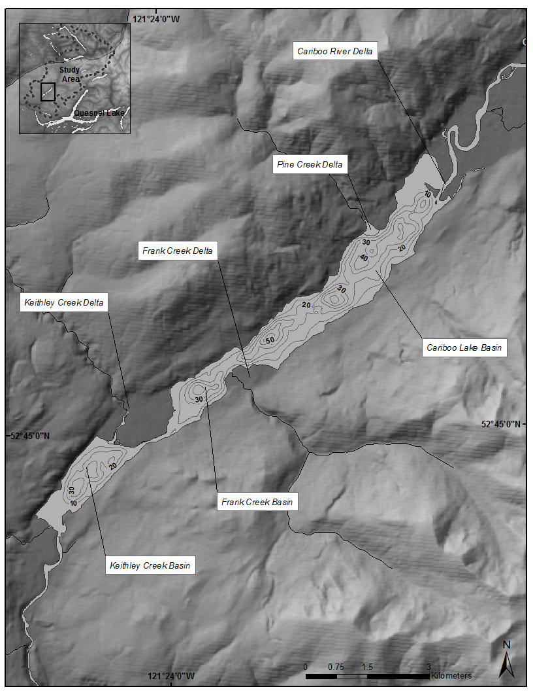

Fig. 1: Cariboo Lake bathymetry. Contour interval is 10 m.

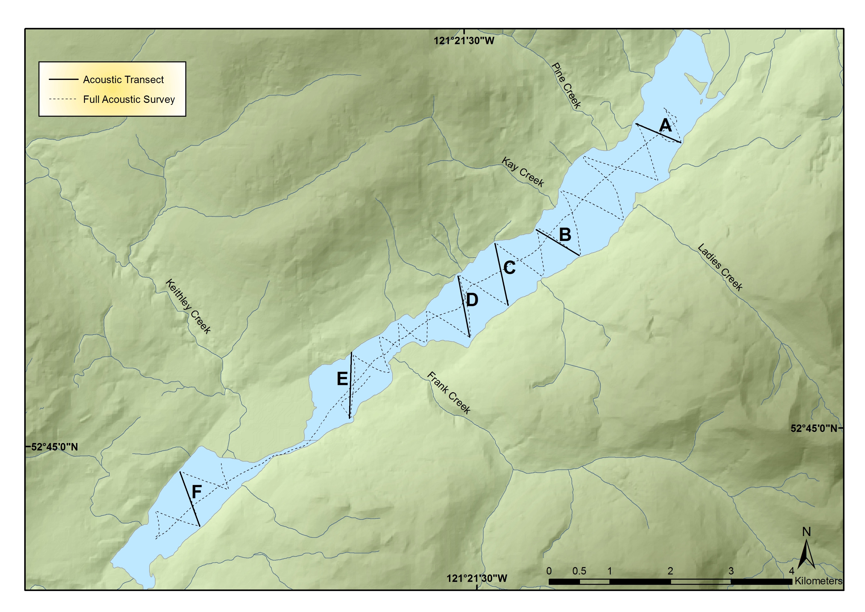

Fig. 2: Cariboo Lake sub-bottom acoustic transects

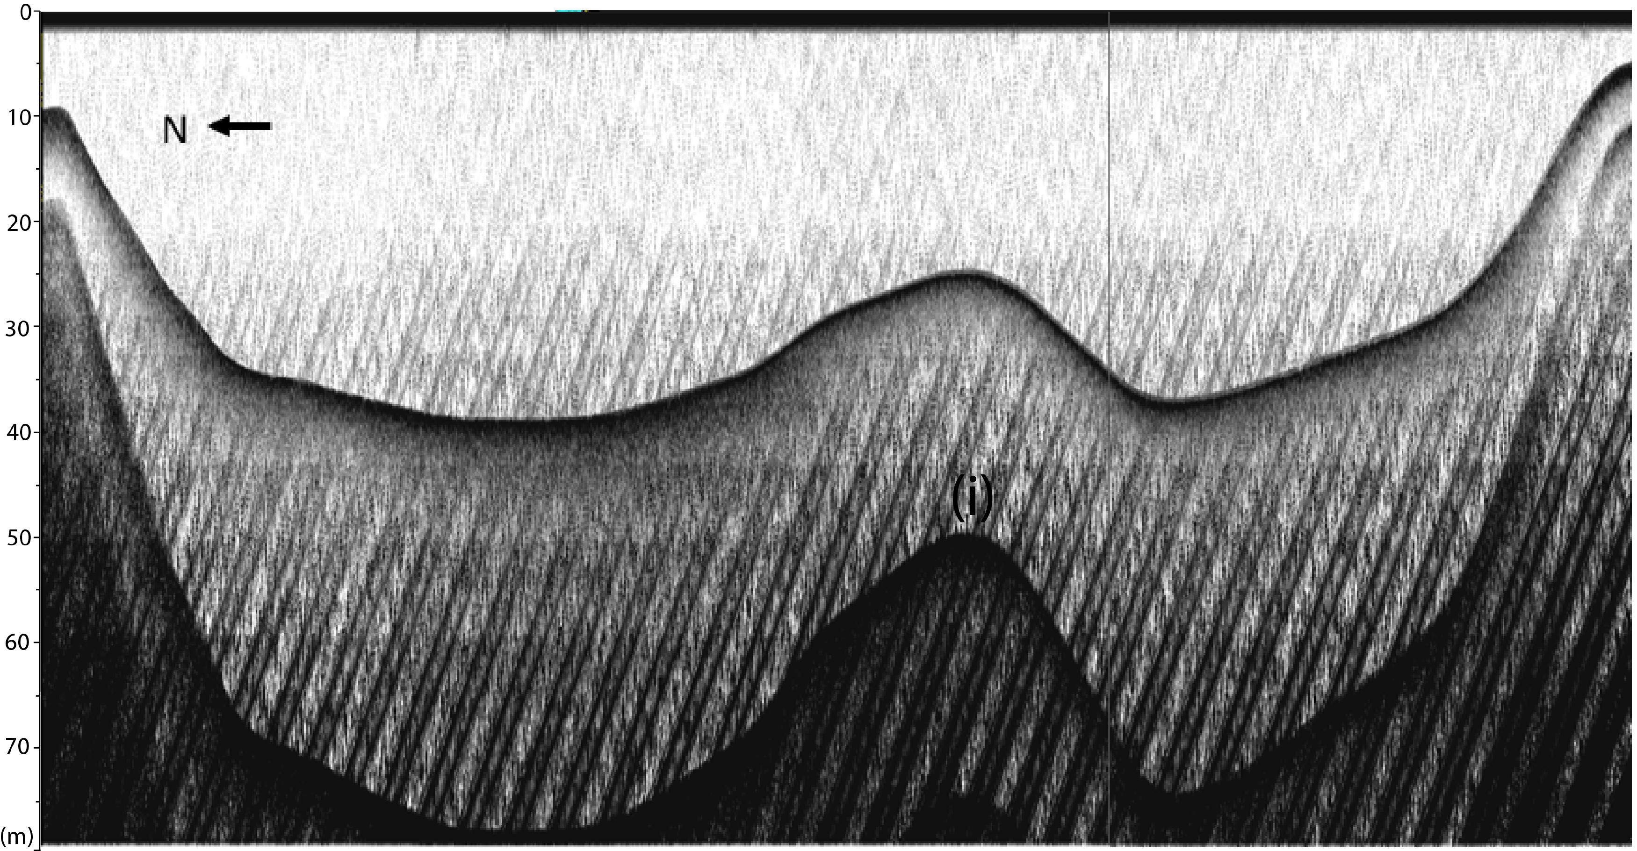

Fig. 3: Sub-bottom acoustic transect A. Duplicate acoustic reflector is denoted by (i). Looking up-lake, see Fig. 3.5 for location.

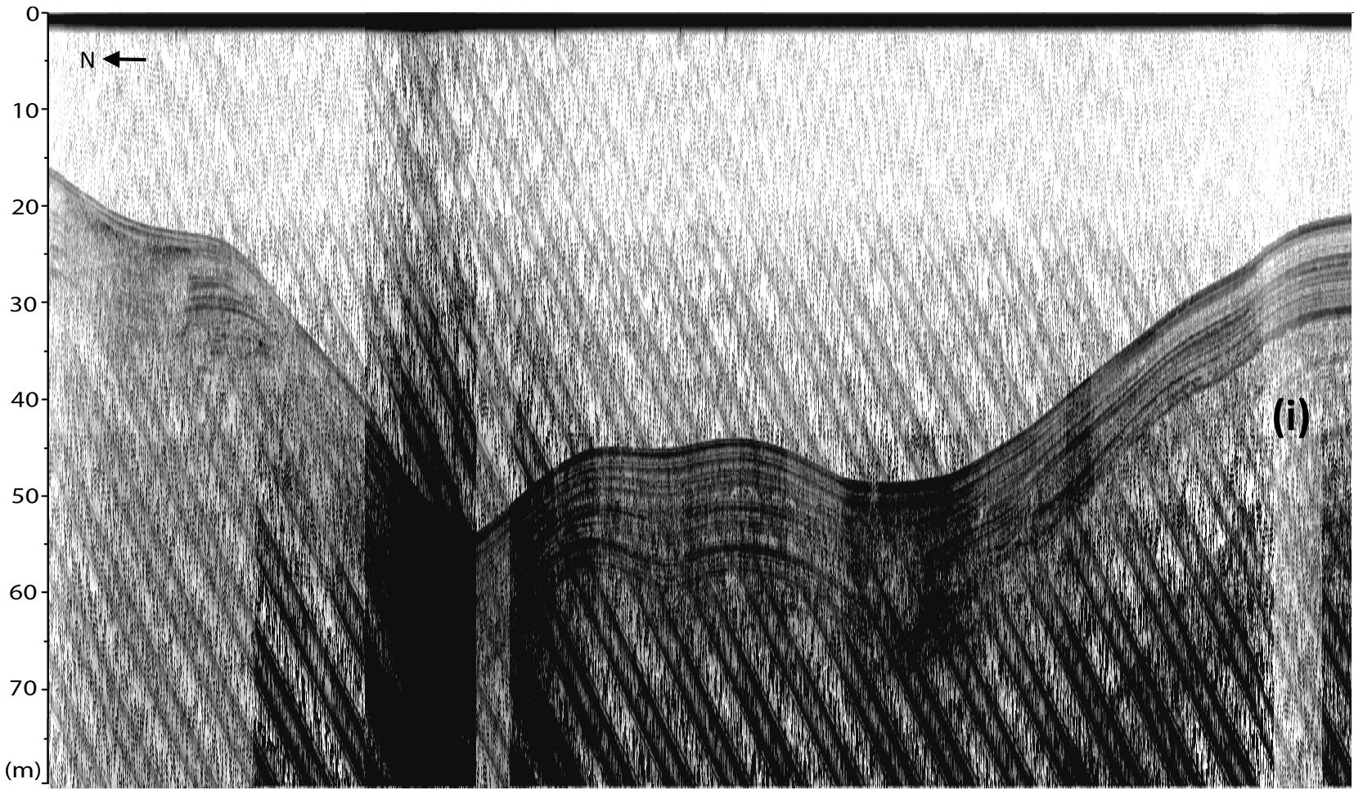

Fig. 4: Sub-bottom acoustic transect B. Looking up-lake, see Fig. 3.5 for location.

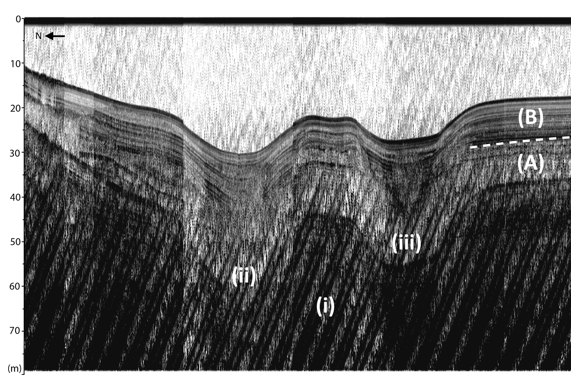

Fig. 5: Sub-bottom acoustic transect C. (i) denotes inferred bedrock or late-glacial material. (ii) and (iii) are v-notch scour channels. (A) and (B) are sediment facies. Looking up-lake, see Fig. 3.5 for location.

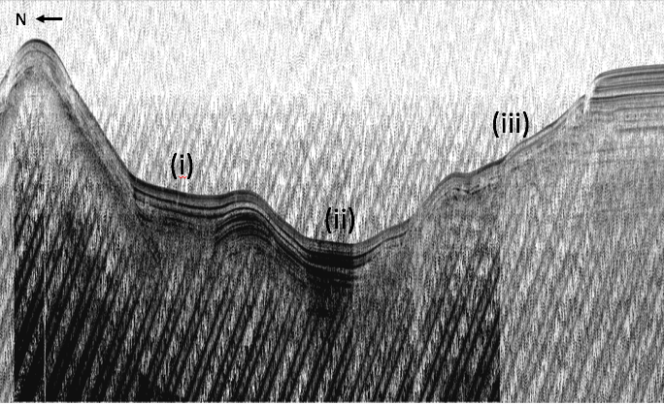

Fig. 6: Sub-bottom transect D. Scour channels are denoted by (i) and (ii). Slumping is observed at (iii). Looking up-lake, see Fig. 3.5 for location.

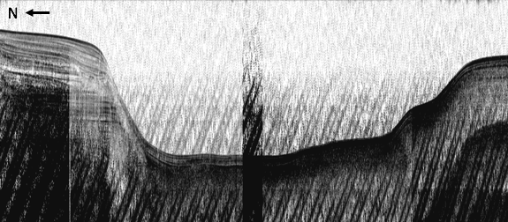

Fig. 7: Sub-bottom acoustic transect E. Looking up-lake, see Fig. 3.5 for location.

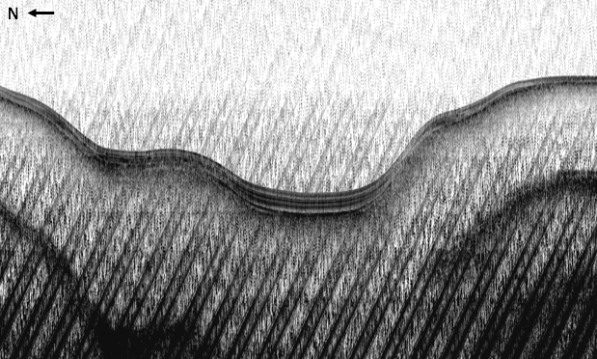

Fig. 8: Sub-bottom acoustic transect F. Looking up-lake, see Fig. 3.5 for location.